If your class has a method where one of the parameters is an object, you need to specify the name of that class in front of the parameter

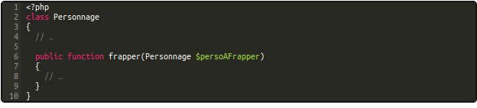
Here we have a simple object with a __construct function. Notice how we are using setters inside of it; construct doesnt dispense you from creating getters and setters (mutateurs)!

Scope Resolution Operator

The :: needed to call a static method or a constant inside the class definition (self::CONSTANT in the definition)

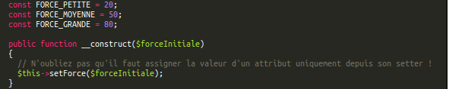

Database and OOP

If the table has as many columns as the object has attributes, it can be used to construct a new instance rapidly as such
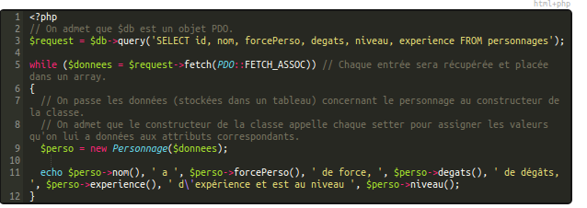
While there are rows of results returned, we pass them one by one to the object, and the setters will take care of the rest, chronologically (??)

hydrate()

In practice, such an example will work if we define a hydrate function. It takes an array as parameter, and loops trhough it, checking whether each key value pair has an equivalent in the class, and hydrates what it can
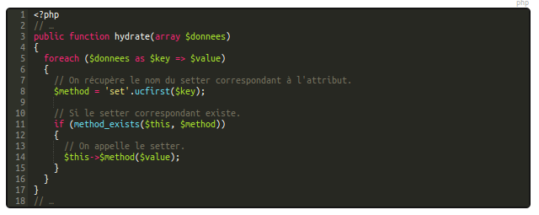
On line 8, ucfirst means you put the first letter of $key in uppercase. This has the output:

$method = setKey();

Back to the DB

This is how a typical db manager class should look like:

